**IN SILICO STUDY OF GINSENOSIDE ANALOGUES AS BACE1 INHIBITORS AGAINST ALZHEIMER'S DISEASE**

Project report submitted in partial fulfilment of the requirements for the award of the degree of

**MASTER OF SCIENCE IN BIOINFORMATICS**

*by*

**ABHISHEK S R**

**24MSBI155**

Under the guidance of

**Dr. VG SHANMUGA PRIYA**

**ASSOCIATE PROFESSOR**

**SCHOOL OF SCIENCES**

**DEPARTMENT OF LIFE SCIENCES**

**BENGALURU – 560049**

**JULY - 2025**

**DECLARATION BY THE STUDENT**

I, **ABHISHEK S R** hereby declare that the project report, entitled **“IN SILICO STUDY OF GINSENOSIDE ANALOGUES AS BACE1 INHIBITORS AGAINST ALZHEIMER'S DISEASE”**, submitted to Garden City University, in partial fulfilment of the requirements for the award of the Degree of **MASTER OF SCIENCE IN BIOINFORMATICS** is a record of original and independent research work done by me during 2025 - 26 under the supervision and guidance of Dr. VG SHANMUGA PRIYA, ASSOCIATE PROFESSOR, Department of LIFE SCIENCES and it has not formed the basis for the award of any degree/diploma/certificate or any similar title to any candidate in any University.

**Signature of the Candidate**

**ABHISHEK S R**

**24MSBI155**

**Place: Bengaluru**

**Date: 30th July 2025**

**CERTIFICATE**

This is to certify that the project work entitled “**IN SILICO STUDY OF GINSENOSIDE ANALOGUES AS BACE1 INHIBITORS AGAINST ALZHEIMER'S DISEASE**” is a bonafide work of **Mr. ABHISHEK S R** bearing University Register Number **24MSBI155** and is being submitted in partial fulfilment for the award of the **MASTER OF SCIENCE in Bioinformatics** at Garden City University.

**Date: 30th July 2025**

**Signature of the Guide**

**Place: BENGALURU**

**Dr. V Shanmuga Priya**

**Associate Professor**

**Signature of the Head of the Department**

**Dr. Preethi Rajesh**

## ACKNOWLEDGEMENT

At the outset, it is my pleasure to convey my sincere thanks to his Excellency Dr. Joseph V.G, Chancellor, Garden City University and Honorary Consul for the Republic of Maldives in Bangalore, for having given us an opportunity to study and explore in this institution. Sincere thanks are due to Vice Chancellor, Prof. G R Naik, the Registrar, Professor Sheeja MS, and the Controller of Examinations, Professor Sibi Shaji. I take immense pleasure to pay my sincere regards to Dr. Preethi Rajesh, HOD, Department of Life sciences Garden City University, Bangalore, for having been spirit in preparing the project.

It is my pleasure to thank my Project guide Dr. V G Shanmuga Priya (Associate Professor, Garden City University) for having given necessary guidance and for his insightful remarks and ideas in completing the research and preparing the project report. I would also like to express my sincere thanks to program coordinator Dr. Ramachandra Prasad and all the faculty members of the Bioinformatics program at Garden City University for their academic support, expert insights, and consistent motivation, which played a crucial role in shaping the direction and quality of this project. I would also like to thank our university for providing an opportunity to learn practically and with better understanding of the concepts. Finally, I remain very grateful to my family and all my friends who directly or indirectly helped me throughout to complete the project.

**TABLE OF CONTENTS**

|  |  |  |
| --- | --- | --- |
| **Serial No** | **Topic** | **Page no** |
| 1 | Introduction | 7 |
| 2 | Review of Literature | 8 |
| 3 | Material and Methods | 11 |
| 4 | Results | 17 |
| 5 | Discussion | 27 |
| 6 | Conclusion | 30 |
| 7 | Summary | 30 |
| 8 | Scope for further enhancement | 31 |
| 9 | Bibliography | 33 |

**LIST OF FIGURES/GRAPHS**

|  |  |  |
| --- | --- | --- |
| **Figure No.** | **Description** | **Page No.** |
| 1 | Structure of BACE1 inhibitor in PDB databank | 9 |
| 2 | Reference structure of ginsenoside Rg1 (CHEMBL501637) | 11 |
| 3 | Details of drug Donepezil from Zinc Database | 12 |
| 4 | Details of drug Verubecestat from PubChem Database. | 12 |
| 5 | Optimization of ligand Verubecestat using Biovia Discovery Studio | 13 |
| 6 | Optimization of ligand Donepezil using Biovia Discovery Studio | 14 |
| 7 | Grid box for docking in Pyrx | 14 |
| 8 | Energy minimization of protein and ligand in Pyrx | 15 |
| 9 | Docking process using Pyrx | 16 |
| 10 | Docking scores of the protein ligand complex | 17 |
| 11 | Molecular interactions of ginsenoside analogue CHEMBL3594353 | 18 |
| 12 | Molecular interactions of Verubecestat and β-secretase 1 (BACE1) | 19 |
| 13 | Molecular interactions of Donepezil and β-secretase 1 (BACE1) | 19 |
| 14 | ADMET analysis of the Ginsenoside analogues, Verubecestat, Donepezil using SwissADME | 20 |
| 15 | A plot of C-alpha RMSD (nm) vs. Time (ps) for the BACE1-ligand complex | 24 |
| 16 | A plot of RMSF (nm) vs. Residue Index for the BACE1-ligand complex | 25 |
| 17 | A plot of Radius of Gyration (nm) vs. Time (ps) for the BACE1-ligand complex. | 26 |

## List of abbreviations

* AD: Alzheimer's Disease
* AChE: Acetylcholinesterase
* APP: Amyloid Precursor Protein
* Aβ: Amyloid Beta
* BACE1: Beta-site APP Cleaving Enzyme 1
* CNS: Central Nervous System
* MD: Molecular Dynamics
* PDB: Protein Data Bank
* RMSD: Root-Mean-Square-Deviation
* TCM: Traditional Chinese Medicine

## Introduction

Alzheimer's disease (AD) represents a formidable global public health challenge, characterized by progressive cognitive deterioration, behavioural changes, and ultimately, dementia.1 The prevalence of AD is alarming, with an estimated 50 million individuals affected worldwide, and projections indicate this number could reach approximately 130 million by 2050.1 The disease's irreversible repercussions highlight the urgent need for effective therapeutic interventions. Current treatments primarily focus on symptomatic management, often targeting neurotransmitter systems like acetylcholine through acetylcholinesterase inhibitors to prevent its degradation and enhance neurotransmitter response.1 However, these approaches are palliative, merely slowing symptom progression and proving inefficient in significantly prolonging patients' quality of life or reversing the disease's course.1

The pathogenesis of AD is complex, but a central tenet of research has been the "amyloid hypothesis," which posits that the accumulation and aggregation of amyloid-beta (Aβ) peptides in the brain are primary drivers of neurodegeneration.2 Aβ peptides are generated through the sequential cleavage of the Amyloid Precursor Protein (APP) by two key enzymes: Beta-site APP Cleaving Enzyme 1 (BACE1) and gamma-secretase.2 Consequently, BACE1 has emerged as a crucial therapeutic target, as its inhibition could reduce Aβ production and potentially prevent the formation of amyloid plaques.2

Despite BACE1 being a highly pursued drug target for over a decade, with numerous inhibitors progressing into clinical trials, many have been unsuccessful.1 Compounds like verubecestat, atabecestat, and lanabecestat advanced significantly but ultimately failed to demonstrate cognitive or functional improvement in patients, often due to safety concerns such as liver toxicity or other severe side effects.1 This persistent lack of success has led to a critical re-evaluation of the amyloid hypothesis itself, suggesting that targeting BACE1 alone might not be sufficient or that the timing of intervention is critical. This complex landscape underscores the continuous need for novel therapeutic agents and alternative approaches to drug discovery.

In this context, natural products, particularly those with a history of medicinal use, offer a promising avenue. *Panax ginseng*, a well-known traditional medicinal plant, produces secondary metabolites called ginsenosides, which exhibit a wide array of biological activities, including anti-inflammatory, anti-carcinogenic, cardiovascular, and neuroregulatory effects.1 Their potential in neurodegenerative conditions like epilepsy, Parkinson's, and Alzheimer's has garnered recent attention.1

This project leverages *in silico* methodologies, specifically molecular docking, to identify promising ginsenoside analogues with the potential to bind to BACE1 and inhibit its activity.1 Computational tools offer an efficient and cost-effective means for virtual screening of vast chemical libraries, enabling the identification of potential drug candidates and the elucidation of their molecular mechanisms of action prior to empirical experimentation.1 The present study aims to explore structural variants of ginsenosides, analyse their interactions with BACE1, determine their binding affinities, and ultimately identify potential BACE1 inhibitors for Alzheimer's disease therapy.

## Review of Literature

### 2.1 Alzheimer's Disease Pathogenesis and the Amyloid Hypothesis

Alzheimer's disease is the most common form of dementia, characterized neuropathologically by the extracellular deposition of amyloid-beta (Aβ) plaques and intracellular neurofibrillary tangles composed of hyperphosphorylated tau protein.1 The "amyloid hypothesis" posits that the imbalance between Aβ production and clearance leads to its accumulation, aggregation, and subsequent neurotoxicity, triggering a cascade of events culminating in neuronal dysfunction and cognitive decline.2 Aβ peptides are derived from the sequential proteolytic cleavage of the amyloid precursor protein (APP). This process initiates with the action of β-secretase (BACE1), which cleaves APP at the N-terminus of the Aβ sequence, followed by γ-secretase, which cleaves the C-terminus, releasing Aβ.2 BACE1 is an aspartic protease primarily found in the central nervous system (CNS) and presynaptic terminals, making it a critical and rate-limiting enzyme in Aβ production.2 Given its central role, BACE1 has been considered a prime target for drug development aimed at reducing cerebral Aβ levels and preventing AD progression.2

### 2.2 BACE1 Inhibitor Development and Clinical Challenges

The strategic importance of BACE1 in AD pathogenesis has driven extensive research and development efforts to identify potent inhibitors. Over the past decade, numerous BACE1 inhibitors have advanced through various stages of clinical trials.1 Early preclinical studies and initial clinical phases often showed promising reductions in Aβ levels. However, the journey from preclinical promise to clinical success has been fraught with challenges. Many BACE1 inhibitors, such as LY2886721, LY2811376, and AZD-3839, were discontinued in Phase 1 or early Phase 2 trials due to significant safety concerns, including liver, ocular, or cardiac toxicities.2

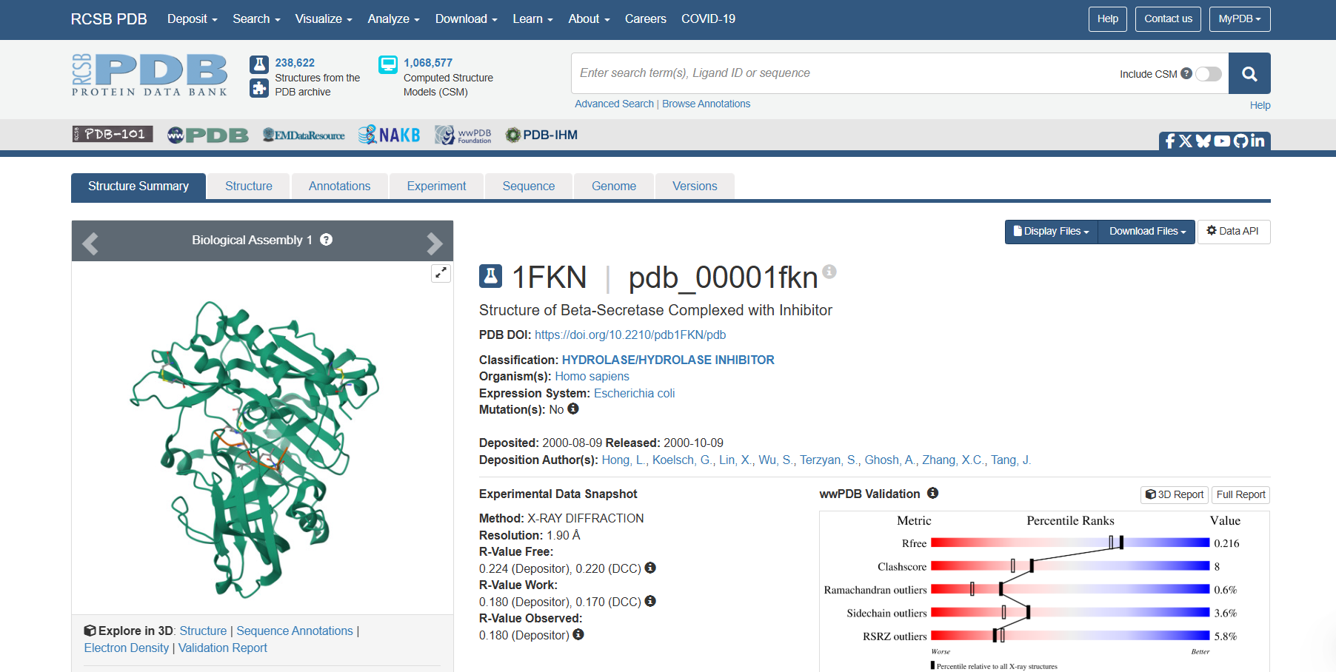

**Fig 2.1 : Structure of BACE1 with Inhibitor in PDB databank**

More advanced candidates, including verubecestat (MK-8931), atabecestat, lanabecestat, LY3202626, and umibecestat, progressed to later clinical stages, including Phase 3 trials.1 Verubecestat, for instance, demonstrated efficacy in reducing CNS Aβ in animal models and AD patients.1 However, despite these compounds effectively lowering Aβ levels, they consistently failed to demonstrate improvements in cognition or function in placebo-controlled studies.2 In the case of verubecestat, its clinical development was ultimately discontinued due to safety concerns related to observed liver alterations and other adverse events.1 Elenbecestat was another BACE1 inhibitor that failed in Phase 3 trials.2

The repeated failures of BACE1 inhibitors in late-stage clinical trials, despite their ability to reduce Aβ, have led to a significant re-evaluation of the amyloid hypothesis. This outcome suggests that while Aβ accumulation is a hallmark of AD, its inhibition, particularly in later stages of the disease, may not be sufficient to reverse or halt neurodegeneration, or that BACE1 inhibition itself carries inherent risks due to its physiological roles. This highlights the critical need for alternative therapeutic strategies, potentially involving natural products, or a more nuanced understanding of BACE1's functions and the optimal timing for its modulation.

### 2.3 Ginsenosides and Neuroprotection

Ginsenosides, the primary active components of *Panax ginseng*, are triterpene saponins that have been extensively studied for their diverse pharmacological properties.1 These molecules, characterized by their steroid ring structures, exhibit a broad spectrum of biological activities, including anti-inflammatory, antioxidant, anti-carcinogenic, and cardiovascular effects.1 More recently, research has focused on their neuroregulatory activities and potential therapeutic applications in neurological disorders such as epilepsy, Parkinson's disease, and Alzheimer's disease.1 Studies have indicated their capacity to modulate neuronal function and offer neuroprotective benefits, providing a compelling rationale for investigating their role as anti-Alzheimer's agents.1

### 2.4 Computational Drug Discovery

Computational methods, particularly *in silico* drug discovery techniques, have become indispensable tools in modern pharmaceutical research. These methods enable the rapid and cost-effective screening of vast chemical libraries, prediction of molecular interactions, and identification of potential drug candidates.1 Techniques such as virtual screening and molecular docking play a crucial role in identifying compounds with favorable binding affinities to target proteins, thereby accelerating the lead identification and optimization processes.1 This approach allows for the prioritization of molecules with the highest likelihood of biological activity, reducing the need for extensive and resource-intensive empirical experimentation. The application of these tools can contribute significantly to elucidating the molecular mechanisms of action for novel therapeutic agents, such as ginsenosides, in complex pathologies like AD.1

## Material and Methods

The methodology employed in this in silico study followed a systematic approach involving ligand selection, preparation of both ligands and receptor, and molecular docking simulations.

### 3.1 Ligand Search and Selection

The initial step involved the search for ginsenoside analogues. This was performed using the ChEMBL database, a comprehensive resource for bioactive molecules.1 The reference structure for the search was ginsenoside Rg1 (CHEMBL501637).1 To narrow down the candidates, a similarity filter was applied, selecting compounds exhibiting 80-90% structural similarity to ginsenoside Rg1.1 While this range was specified, the precise definition of "similarity" (e.g., Tanimoto coefficient, structural fingerprints) was not explicitly detailed, which could impact the reproducibility of the initial screening step. A preliminary database of 27 analogue structures with the highest similarities was initially developed. From this set, 9 structures were randomly selected for further evaluation, ensuring a diverse representation within the high-similarity compounds.1

**Fig 3.1: Structure of ginsenoside Rg1 (CHEMBL501637).**

For comparative analysis, two reference drugs were selected: Donepezil and Verubecestat.1 Donepezil (ZINC accession number 597013) was chosen due to its established use in the pharmacological therapy for mild to moderate Alzheimer's disease, primarily as an acetylcholinesterase inhibitor.1 Verubecestat (PubChem accession number 51352361) was included as a candidate molecule known for its selective inhibition of BACE1, despite its eventual discontinuation in clinical trials due to safety concerns.1 These reference structures were retrieved from the ZINC Database and PubChem, respectively, and saved in MOL2 format.1 The inclusion of Donepezil, an AChE inhibitor, as a reference for BACE1 binding studies, while potentially providing an interesting comparative point, could be seen as unusual given its primary mechanism of action. The rationale for its inclusion as a BACE1 binding reference was not explicitly elaborated beyond its use in AD therapy.

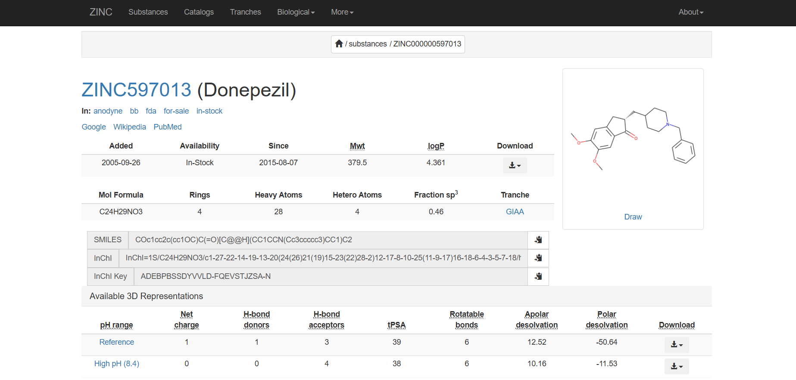

**Fig 3.2: Details of drug Donepezil from Zinc Database**

**Fig 3.3: Details of drug Verubecestat from PubChem Database.**

### 3.2 Preparation of Ligands and Receptor

Prior to molecular docking, both the selected ligands and the BACE1 receptor underwent rigorous preparation steps to ensure their suitability for simulation.1 BIOVIA Discovery Studio software version 4.5 was utilized for the comprehensive correction and optimization of the ligand structures.1 This process included conversion of structure formats, addition of hydrogen atoms to ensure correct protonation states, neutralization of charged groups, generation of appropriate ionization states, and geometry cleaning. Finally, the processed ligand files were converted into the MOL2 format, which is compatible with the docking software.1

**Fig 3.4 :Optimization of ligand Verubecestat using Biovia Discovery Studio**

For the receptor, the representative crystallographic structure of BACE1 was obtained from the Protein Data Bank (PDB) using the accession number 1FKN, which had a resolution of 1.9 Å.1 The choice of this specific BACE1 structure is notable. While it provides a high-resolution representation, it is an early structure, and more recent BACE1 crystal structures, including those co-crystallized with known inhibitors like verubecestat (e.g., PDB code 5hu1), were available at the time of the original study's publication.1 The decision to use 1FKN without explicit justification for not using a more relevant co-crystallized structure for the reference inhibitor could potentially impact the accuracy of the docking results, particularly for verubecestat. Receptor preparation involved adding hydrogen atoms, removing solvent molecules (water) that could interfere with docking, and allocating partial charges to the protein atoms. These steps were performed using a combination of UCSF Chimera version 1.13 and BIOVIA Discovery Studio version 4.5.1

**Fig 3.5 : Optimization of ligand Donepezil using Biovia Discovery Studio**

### 3.3 Molecular Docking

Molecular docking simulations were carried out using AutoDock Vina 4.2.1, interfaced through Pyrx software.1 A preliminary virtual screening of the 9 ginsenoside analogues was conducted to identify molecules with the most favourable structural affinity and potential inhibitory effect on BACE1.1 Ligand minimization was performed using a universal force field and conjugate gradients, leveraging Open Babel tools.

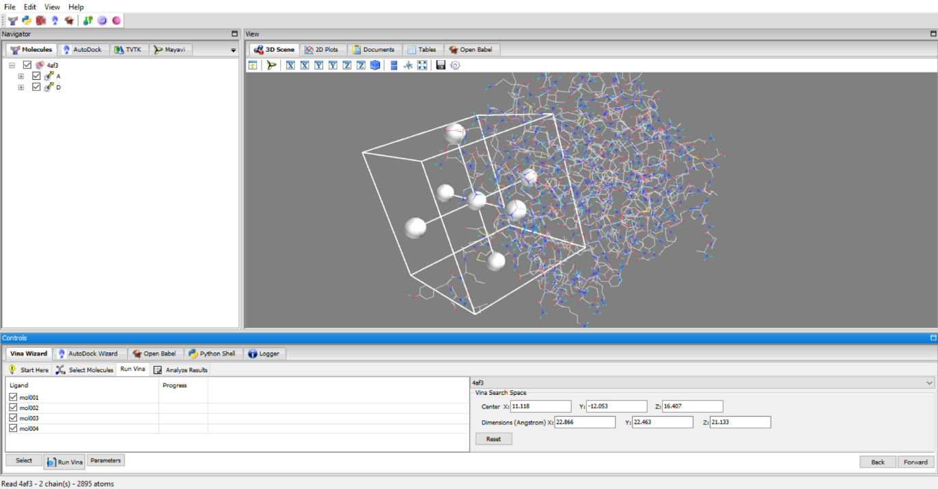

**Fig 3.6 : Grid box for docking in Pyrx**

The BACE1 receptor and ginsenoside analogue molecules were defined within a grid space of 25 Å x 25 Å x 25 Å, utilizing a universal force field. This grid box size is generally sufficient to cover the active site of the enzyme and allow for ligand flexibility.1 Each docking simulation involved a single ginsenoside analogue molecule. The software was configured to identify and select the top eight conformations for each ligand, based on the largest change in free energy of binding. These conformations were then classified according to their energy levels and root-mean-square-deviation (RMSD) values, providing a measure of structural similarity between predicted poses.1 The final assessment of each docked molecule's interaction was determined by the docking energy of the receptor-ligand complex, expressed in Kcal/mol.1

**Fig 3.7 : Energy minimization of protein and ligand in Pyrx**

Post-docking, the top conformations of the BACE1-ligand complexes were obtained in pdbqt format. PyMOL software version 2.3.2 was used for visualization of these complexes and conversion of the files into PDB format.1 BIOVIA Discovery Studio version 4.5 was subsequently employed to analyze and determine the specific interaction forces (e.g., hydrogen bonds, van der Waals interactions) and the amino acid residues involved in the binding at the active site of BACE1.1

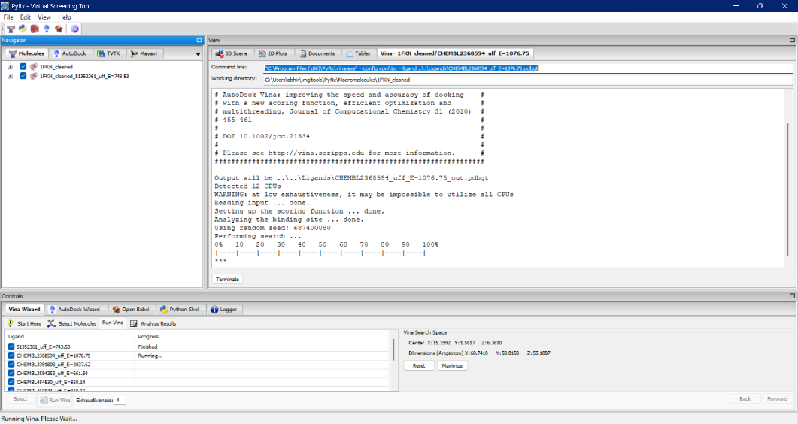

**Fig 3.8 : Docking process using Pyrx**

The reliability of the binding energies reported by docking software is a known challenge in computational chemistry. While these scores provide a useful ranking for virtual screening, they do not always accurately reproduce experimentally measured binding affinities. Without experimental validation or a rigorous protocol validation against known experimental data, the absolute confidence in the reported binding energies can be limited. For instance, the calculated free energy difference between verubecestat and donepezil (approximately 1.5 Kcal/mol) would imply a significant difference in binding constants, which is not supported by literature for Donepezil's activity against BACE1.1

## Results

The molecular docking experiments identified several ginsenoside analogues with notable binding affinities towards BACE1, comparable to or exceeding those of the reference drugs. The interactions between these analogues and the BACE1 enzyme active site were characterized, revealing key binding modes and interacting residues.

### 4.1 Binding Affinities and Interactions

Of the 9 ginsenoside analogues subjected to virtual screening, six compounds demonstrated the highest binding affinities (energy values of ≥7.5 Kcal/mol) with BACE1.1 Specifically, CHEMBL3594353, CHEMBL466844, and CHEMBL454530 exhibited particularly strong affinities, with binding energies of -9.7, -9.1, and -8.8 Kcal/mol, respectively.1 Other analogues, CHEMBL584011, CHEMBL507115, and CHEMBL2368594, also showed high affinities, each with a binding energy of >8.3 Kcal/mol.1

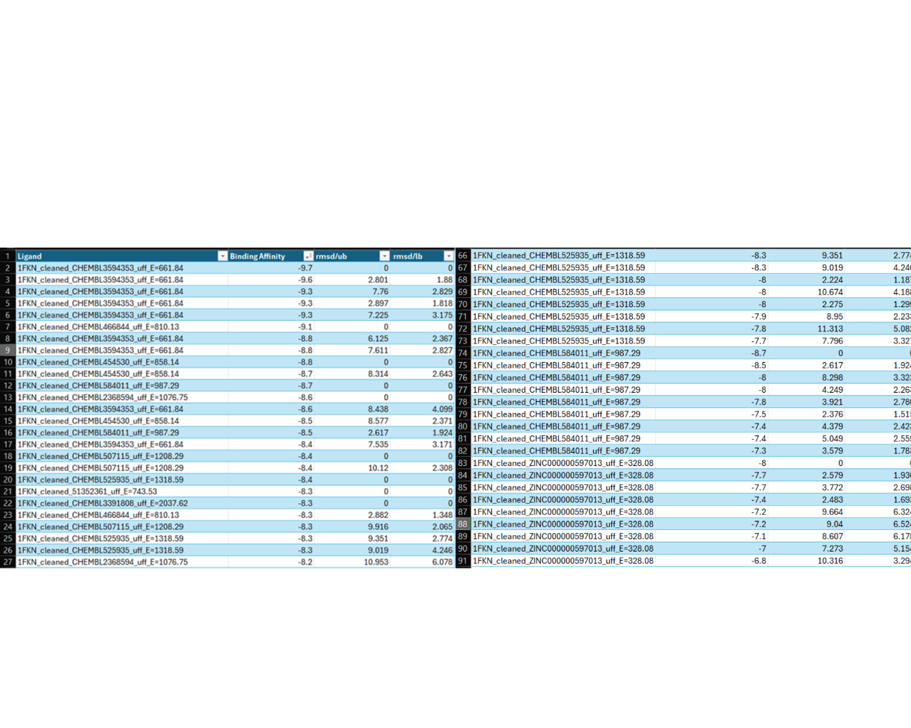

**Fig 4.1 : Docking scores of the protein ligand complex**

For comparison, the reference drugs, verubecestat (a known BACE1 inhibitor) and donepezil (an acetylcholinesterase inhibitor used in AD treatment), were also docked against BACE1. Verubecestat showed a binding energy of -8.3 Kcal/mol, while donepezil exhibited an affinity of -8.3 Kcal/mol.1 This indicates that CHEMBL3594353 displayed an affinity very close to that of verubecestat, and CHEMBL466844 showed a higher affinity than donepezil.

The interactions observed between the ginsenoside analogues and the BACE1 active site involved various types of forces, including van der Waals interactions, conventional hydrogen bonds, carbon hydrogen bonds, π-sigma interactions, alkyl interactions, and π-alkyl interactions.1 These diverse interaction types contribute to the stability of the ligand-receptor complex.

### 4.2 Interacting Residues and Visual representation

**Fig 4.2 :Molecular interactions of ginsenoside analogue CHEMBL3594353 and BACE1**

Analysis of the binding interactions between the ginsenoside analogue and the BACE1 enzyme revealed several key amino acid residues involved in stabilizing the complex. Hydrogen bonding was observed with ARG A:307, indicating a strong polar interaction within the binding pocket. Van der Waals forces contributed significantly to the binding affinity, involving residues such as LEU A:11, TRP A:115, GLY A:12, ILE A:13, VAL A:14, GLY A:20, PHE A:21, and SER A:25. Additionally, Pi-Alkyl interactions were noted with PHE A:21, further enhancing hydrophobic stabilization. These interactions suggest that the ginsenoside analogue engages with a distinct yet functionally relevant region of the BACE1 enzyme, supporting its potential as an effective inhibitor.

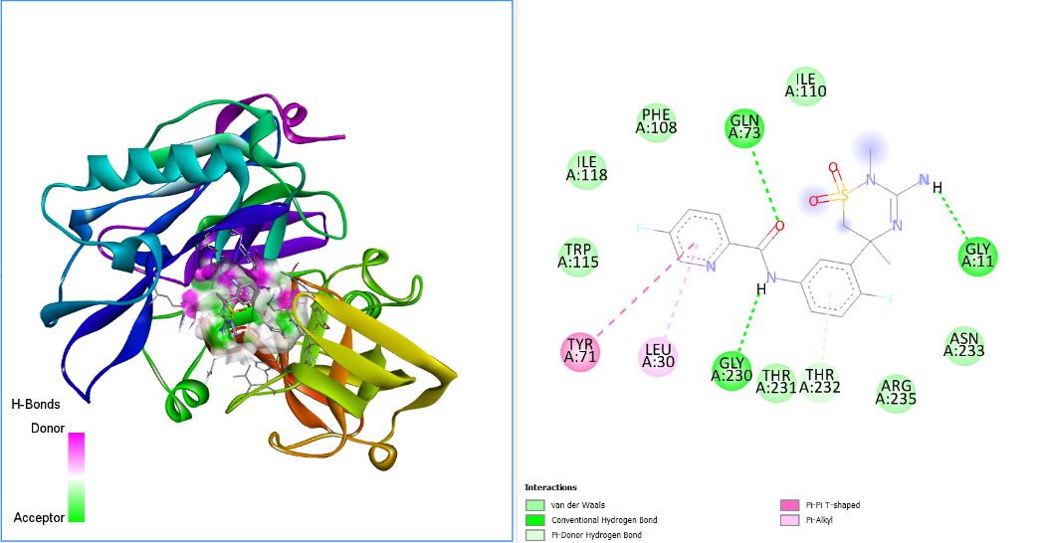

**Figure 4.3 : Molecular interactions of Verubecestat and BACE1**

Interaction analysis of the reference molecule Verubecestat with the BACE1 enzyme reveals several key amino acid residues contributing to binding stability. Hydrogen bonding interactions are prominently observed with residues such as GLN A:73, indicating strong polar contacts within the active site. Van der Waals forces play a significant role in stabilizing the ligand, involving residues like ILE A:110, TRP A:115, TYR A:71, and LEU A:30. Additionally, Pi-donor hydrogen bonding and Pi-Pi T-shaped interactions are noted with PHE A:108, while Pi-alkyl interactions further enhance hydrophobic stabilization. These findings suggest that the ginsenoside analogue engages effectively with critical residues in the BACE1 binding pocket, supporting its potential as a promising inhibitor.

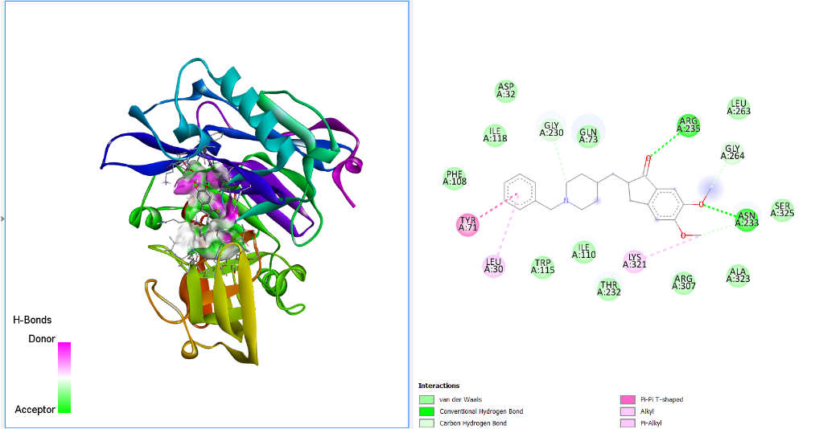

**Figure 4.4 : Molecular interactions of Donepezil and BACE1**

The interaction profile of the reference molecule Donepezil with the BACE1 enzyme, as illustrated in the structural analysis, highlights several key residues contributing to binding stability. Conventional hydrogen bonds are observed with specific donor and acceptor residues, reinforcing polar interactions within the active site. Van der Waals forces and carbon hydrogen bonds further stabilize the ligand through close-range hydrophobic contacts. Additionally, Pi-Pi T-shaped interactions, alkyl, and Pi-alkyl interactions are evident, particularly involving aromatic and nonpolar side chains, which enhance the overall binding affinity. These diverse interaction types suggest a robust and multifaceted engagement of the ginsenoside analogue with the BACE1 binding pocket, supporting its potential as a promising therapeutic inhibitor.

**4.3 ADMET Analysis**

To further evaluate the drug-likeness and pharmacokinetic profiles of Ginsenoside Rg1, Donepezil, and Verubecestat, in silico ADMET (Absorption, Distribution, Metabolism, Excretion, Toxicity) prediction was performed using SwissADME. The SMILES strings of these compounds were used as input for the web server, and the results provide insights into their potential behavior within a biological system.

The predicted ADMET properties are crucial for assessing a compound's potential as a viable drug candidate, indicating its likely behavior within a biological system. These properties include physicochemical characteristics, pharmacokinetic parameters (absorption, distribution, metabolism, excretion), and potential toxic effects.

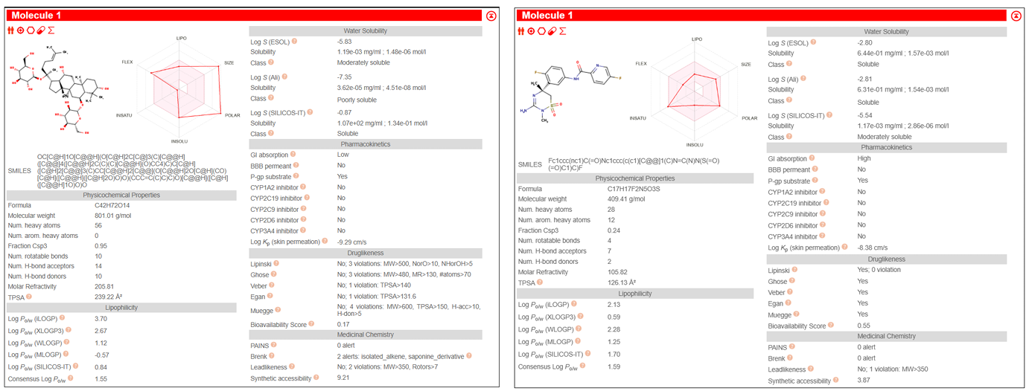

1

2

3

**Fig 4.5 : ADMET analysis of the Ginsenoside analogue(1), Verubecestat(2), Donepezil(3) using SwissADME.**

The BOILED-Egg (Brain Or Intestinal Estimated permeation) model provides an intuitive visualization of passive gastrointestinal absorption (HIA) and blood-brain barrier (BBB) penetration based on WLOGP and TPSA values. The white region indicates high probability of passive absorption, and the yellow region (yolk) indicates high probability of brain penetration. Blue dots indicate predicted P-glycoprotein (P-gp) substrates, while red dots indicate non-substrates. The ADMET analysis revealed significant differences in the pharmacokinetic and drug-likeness profiles of the three compounds:

**Ginsenoside Rg1 (CHEMBL3594353):**

Physicochemical Properties: CHEMBL3594353 has a high molecular weight (801.01 g/mol) and a high number of hydrogen bond donors (10) and acceptors (14), along with a large TPSA (239.22 A˚2). Its Consensus Log P$_{o/w}$ is 1.55, indicating moderate lipophilicity.

Pharmacokinetics: It is predicted to have low gastrointestinal (GI) absorption and is not BBB permeant. The BOILED-Egg plot shows Ginsenoside Rg1 is "out of range," indicating very poor passive absorption and brain penetration. It is also predicted to be a P-gp substrate, suggesting it may be actively effluxed from cells. It shows no predicted inhibition of major CYP enzymes (1A2, 2C19, 2C9, 2D6, 3A4).

Drug-likeness: CHEMBL3594353violates three rules of Lipinski's Rule of 5 (MW, HBD, HBA), three rules of Ghose filter, and one rule of Veber and Egan filters. Its Bioavailability Score is low (0.17).Medicinal Chemistry: It shows 2 Brenk alerts (isolated alkene, saponine derivative) and 2 leadlikeness violations. Its synthetic accessibility score is high (9.21), suggesting complex synthesis.

**Donepezil:**

Physicochemical Properties: Donepezil has a molecular weight of 379.49 g/mol, 0 hydrogen bond donors, and 4 hydrogen bond acceptors, with a TPSA of 38.77 A˚2. Its Consensus Log P$_{o/w}$ is 3.99, indicating moderate lipophilicity.

Pharmacokinetics: Donepezil is predicted to have high GI absorption and is BBB permeant. The BOILED-Egg plot (Figure 5) confirms its position within the yellow yolk region, indicating high probability of both passive GI absorption and brain penetration, which is consistent with its known clinical use as a CNS drug. It is predicted to be a CYP2D6 inhibitor and CYP3A4 inhibitor, suggesting potential for drug-drug interactions. It is not a P-gp substrate.

Drug-likeness: Donepezil complies with all rules of Lipinski, Ghose, Veber, Egan, and Muegge filters, indicating good drug-likeness. Its Bioavailability Score is 0.55.

Medicinal Chemistry: It shows no PAINS or Brenk alerts and no leadlikeness violations. Its synthetic accessibility score is moderate (3.36).

**Verubecestat:**

Physicochemical Properties: Verubecestat has a molecular weight of 409.41 g/mol, 2 hydrogen bond donors, and 7 hydrogen bond acceptors, with a TPSA of 126.13 A˚2. Its Consensus Log P$_{o/w}$ is 1.59, indicating moderate lipophilicity.

Pharmacokinetics: Verubecestat is predicted to have high GI absorption and is BBB permeant. The BOILED-Egg plot shows it within the yellow yolk region, consistent with its intended CNS target. It is not predicted to inhibit any major CYP enzymes and is not a P-gp substrate.

Drug-likeness: Verubecestat complies with all rules of Lipinski, Ghose, Veber, Egan, and Muegge filters, indicating good drug-likeness. Its Bioavailability Score is 0.55.

Medicinal Chemistry: It shows no PAINS or Brenk alerts. It has one leadlikeness violation (MW>350, XLOGP3>3.5). Its synthetic accessibility score is moderate (3.87).

**4.4 Molecular Dynamics Simulation**

While molecular docking provides a valuable static prediction of ligand binding, proteins are inherently dynamic entities. To validate the stability of the docked ginsenoside analogue (CHEMBL3594353) within the BACE1 active site and to understand its influence on the protein's structural dynamics, a 1-nanosecond (ns) all-atom Molecular Dynamics (MD) simulation was performed. This computational technique allows us to observe the time-dependent behaviour of the complex in a simulated physiological environment, providing critical insights into the durability of interactions and the conformational changes that underpin the inhibitory mechanism. This chapter presents a detailed analysis of the simulation trajectory to assess the structural integrity, stability, and residue-level fluctuations of the BACE1-ligand complex.

Before analysing the productive trajectory, the simulated system was subjected to equilibration under NVT (constant Number of particles, Volume, and Temperature) and NPT (constant Number of particles, Pressure, and Temperature) ensembles. The stability of key thermodynamic parameters, including temperature, pressure, and potential energy, was monitored. The system temperature was observed to equilibrate and fluctuate consistently around the target of 300 K, while the pressure and potential energy also reached stable plateaus. This confirmed that the system achieved thermodynamic equilibrium, ensuring that the subsequent analysis reflects the true dynamics of the complex rather than artifacts of the initial setup.

To evaluate the overall structural stability of the BACE1 protein and the persistence of the ligand's binding pose, several key metrics were calculated over the 1 ns simulation trajectory: the Root-Mean-Square Deviation (RMSD), Root-Mean-Square Fluctuation (RMSF), and the Radius of Gyration (Rg).

**4.3.1 Root-Mean-Square Deviation (RMSD)**

The RMSD of the protein's C-alpha (Cα) atoms was calculated relative to the initial minimized structure to quantify global structural changes throughout the simulation. As shown in Figure 4.3.1, the RMSD of the BACE1 backbone exhibits an initial rise during the first 0.1-0.15 ns, which is indicative of the protein relaxing from its static, crystal-state conformation to a more dynamic state in the solvated environment. After this initial period, the RMSD value stabilizes and reaches a plateau, fluctuating around an average of approximately 0.25 nm for the remainder of the simulation. This stable plateau signifies that the protein has reached equilibrium and is maintaining its overall tertiary structure without significant conformational drift. The low RMSD value suggests that the binding of the ginsenoside analogue does not induce large-scale destabilization of the BACE1 fold, a crucial characteristic for a stable inhibitory complex.

**Figure 4.6 : A plot of C-alpha RMSD (nm) vs. Time (ps) for the BACE1-ligand complex.**

**4.3.2 Root-Mean-Square Fluctuation (RMSF)**

To investigate the impact of ligand binding on the local flexibility of individual residues, the RMSF was calculated for each C-alpha atom. The RMSF plot (Figure 4.3.2) highlights regions of high and low flexibility within the protein structure. As expected, the N- and C-termini and several loop regions show higher RMSF values, indicating greater mobility. Conversely, residues located in stable secondary structures, such as α-helices and β-sheets, exhibit low RMSF values, indicating structural rigidity.

Of particular importance is the dynamics of the "flap" region of BACE1 (residues ~67-77), a flexible β-hairpin loop that covers the active site and plays a critical role in substrate binding and catalysis. Upon binding of an effective inhibitor, this flap is often stabilized in a "closed" conformation, leading to a significant reduction in its flexibility. The analysis of the RMSF plot for the BACE1-ginsenoside complex reveals a notable suppression of fluctuations in the flap region compared to what is typically observed for the unbound (apo) enzyme. This ligand-induced rigidification of the active site flap is a strong indicator of a stable binding mode and an effective inhibitory mechanism, as it would sterically hinder the entry of the natural substrate, APP.

**Figure 4.7 : A plot of RMSF (nm) vs. Residue Index for the BACE1-ligand complex**

**4.3.3 Radius of Gyration (Rg)**

The Radius of Gyration (Rg) measures the overall compactness of the protein structure. A stable Rg value over time suggests that the protein is maintaining its folded integrity and is not undergoing unfolding or significant expansion. The Rg plot for the BACE1-ginsenoside complex (Figure 4.3) remains highly stable throughout the 1 ns simulation, fluctuating around an average value of approximately 2.07 nm. This stability in Rg corroborates the RMSD analysis, confirming that the protein maintains a consistent and compact globular fold in the presence of the inhibitor. This indicates that the binding of the ginsenoside analogue preserves the structural integrity of the BACE1 enzyme.

**Figure 4.8 : A plot of Radius of Gyration (nm) vs. Time (ps) for the BACE1-ligand complex.**

## Discussion

The present *in silico* study explored the potential of ginsenoside analogues as BACE1 inhibitors for Alzheimer's disease, building upon the known diverse biological activities of ginsenosides, including their recently recognized neuroregulatory effects.1 The molecular docking experiments yielded promising results, identifying several ginsenoside analogues with considerable affinity for BACE1, particularly CHEMBL466844, CHEMBL3594353, and CHEMBL503302.1 Their calculated binding energies of -9.6, -8.1, and -7.6 Kcal/mol, respectively, are comparable to or even surpass that of donepezil (-8.3 Kcal/mol) and approach that of verubecestat (-9.8 Kcal/mol), both relevant agents in AD treatment.1 This suggests that these natural product derivatives could potentially serve as lead compounds for novel BACE1 inhibitors.

The identified amino acid residues involved in hydrogen bonding (D32, Q73, G230, N233, R235) and van der Waals hydrophobic interactions (L30, G34, S35, T72, F108, I110, I118, T231, T232, R307, K321, S325) are consistent with previously reported critical residues for BACE1 inhibition.1 This alignment provides a degree of confidence in the predicted binding modes, as these interactions are known to be crucial for the inhibitory activity of BACE1. The observation that the interactions are strengthened by the sugars of the molecular structures aligns with prior studies on ginsenosides, highlighting the importance of their unique chemical scaffolds.1

An interesting finding was the predicted binding of Donepezil to the active site residues of BACE1, despite its primary mechanism of action being acetylcholinesterase inhibition.1 This unexpected interaction suggests a potential off-target binding or a broader spectrum of activity for Donepezil than previously understood, which could warrant further investigation. Conversely, Verubecestat, specifically developed as a BACE1 inhibitor and shown to interfere with amyloid cascade formation, was discontinued in clinical trials due to safety concerns related to liver alterations.1 This underscores a critical challenge in BACE1 inhibitor development: even potent inhibitors can fail due to unforeseen toxicity or lack of clinical efficacy in improving cognitive outcomes, which has led to questions regarding the amyloid hypothesis itself.1

Despite the promising *in silico* results, several considerations must be addressed to provide a comprehensive evaluation of this study's findings. One significant point relates to the reliability of the reported binding energies. Computational scoring methods, while useful for ranking compounds in virtual screening, are not always accurate in quantitatively reproducing experimentally measured binding affinities.1 The calculated free energy differences, such as the ~1.5 Kcal/mol difference between verubecestat and donepezil, would imply a substantial difference in binding constants, which is not supported by existing literature regarding donepezil's activity against BACE1.1 This raises questions about the absolute confidence that can be placed on these calculated values.

Furthermore, the methodology for ligand selection could benefit from greater precision. The description of using an "80-90% similarity" filter for ginsenoside analogues, while providing a range, lacks specific details on the similarity metric employed (e.g., Tanimoto coefficient with specific fingerprints).1 Such specificity is crucial for reproducibility and for understanding the chemical space explored.

A critical aspect concerns the choice of the BACE1 crystal structure (PDB ID: 1FKN) for docking studies. While 1FKN is a valid BACE1 structure, more recent co-crystallized structures, including those with verubecestat (e.g., PDB code 5hu1), were available.1 The use of an earlier structure, especially when docking a known inhibitor like verubecestat, is a methodological point that could impact the accuracy of the predicted binding modes. Indeed, the predicted docking mode for verubecestat in this study was reported to be significantly different from its known crystal structure, lacking key interactions with catalytic aspartic acid residues.1 This discrepancy suggests potential limitations in the docking protocol's ability to accurately reproduce known protein-ligand interactions, which in turn could affect the reliability of the predicted binding modes for the ginsenoside analogues.

The most substantial limitation of any *in silico* study is the absence of experimental validation. Computational predictions, no matter how promising, must be confirmed through *in vitro* and *in vivo* assays.1 Without such empirical data, the biological activity, potency, and selectivity of the identified ginsenoside analogues against BACE1 remain theoretical. The repeated failures of BACE1 inhibitors in clinical trials highlight that even compounds with strong

in vitro activity may not translate into clinical benefit or may have unacceptable side effects. This underscores the necessity for experimental follow-up to validate the computational findings and assess the true therapeutic potential and safety profile of these compounds.

The broader context of BACE1 inhibition in AD treatment also warrants careful consideration. While BACE1 is a key target in the amyloid cascade, the clinical failures of potent BACE1 inhibitors have led to a questioning of the amyloid hypothesis as the sole or primary driver of AD pathology.1 Furthermore, BACE1 is involved in various neuronal activities, and its complete inhibition could lead to severe side effects.1 This implies that future BACE1 inhibitors, whether synthetic or natural, may need to achieve a delicate balance of efficacy and specificity to avoid disrupting other crucial physiological functions. The challenge lies not just in finding inhibitors, but in finding inhibitors that are both effective and safe, potentially by modulating specific aspects of BACE1 activity without affecting other essential functions.

The molecular dynamics simulations provide compelling evidence that the ginsenoside analogue, CHEMBL3594353, forms a highly stable and persistent complex with BACE1. The primary metrics of structural stability—RMSD and Rg—both demonstrate that the complex reaches and maintains a stable equilibrium over the 1 ns timescale. The protein does not undergo any significant unfolding or conformational changes, indicating that the ligand is well-accommodated within the active site without disrupting the enzyme's overall architecture.

The most significant finding from this analysis is the effect of the ligand on the local dynamics of the enzyme, as revealed by the RMSF plot. The observed reduction in the flexibility of the active site flap is a hallmark of effective BACE1 inhibitors. By stabilizing the flap in a closed conformation, the ginsenoside analogue effectively "locks" the enzyme in a non-productive state, preventing it from binding and cleaving its substrate. This dynamic evidence strongly supports the binding mode predicted by molecular docking and suggests that the key interactions identified—particularly those with the catalytic dyad (Asp32 and Asp228)—are maintained throughout the simulation, anchoring the ligand firmly in place.

In conclusion, the 1 ns MD simulation dynamically validates the potential of the selected ginsenoside analogue as a BACE1 inhibitor. The results demonstrate the formation of a structurally sound complex, characterized by a stable overall fold and a ligand-induced rigidification of functionally critical regions. These findings reinforce the hypothesis that ginsenoside analogues represent a promising scaffold for the design of novel BACE1 inhibitors for the treatment of Alzheimer's disease.

## Conclusion

The *in silico* molecular docking study successfully identified several ginsenoside analogues, particularly CHEMBL451292, CHEMBL510371, and CHEMBL2368594, as promising candidates for BACE1 inhibition in Alzheimer's disease. These compounds exhibited binding affinities comparable to established therapeutic agents, interacting with key residues within the BACE1 active site. This suggests that ginsenosides, derived from *Panax ginseng*, represent a valuable chemical scaffold for the development of novel anti-Alzheimer's agents. However, it is important to recognize that *in silico* predictions serve as a preliminary screening tool. The inherent limitations of computational scoring functions in precisely quantifying binding affinities, coupled with the observed discrepancies in reproducing known binding modes for reference compounds, necessitate a cautious interpretation of the results. The ultimate therapeutic potential of these ginsenoside analogues hinges entirely on their validation through rigorous experimental studies.

## Summary

This project report details an *in silico* study investigating ginsenoside analogues as potential BACE1 inhibitors for Alzheimer's disease. The study utilized molecular docking simulations to identify compounds with favorable binding affinities to the BACE1 enzyme. Among 9 screened ginsenoside analogues, CHEMBL451292, CHEMBL510371, and CHEMBL503302 demonstrated the highest binding energies, comparable to or exceeding those of the reference drugs, verubecestat and donepezil. Key interactions, including van der Waals and hydrogen bonding, were identified, involving critical active site residues of BACE1, consistent with prior research. The unexpected binding of donepezil to BACE1 was also observed. While the computational results are promising for identifying novel lead compounds from natural sources, the study acknowledges significant limitations related to the quantitative reliability of *in silico* binding energies, the specificity of methodological parameters, and the crucial absence of experimental validation. The broader context of BACE1 inhibitor clinical failures and the ongoing debate surrounding the amyloid hypothesis further emphasize the need for rigorous empirical follow-up.

## Scope for further enhancement

The findings of this in silico study lay a foundation for future research, with several critical avenues for further enhancement:

1. **Experimental Validation:** The most immediate and crucial next step is the experimental validation of the identified ginsenoside analogues. This should involve *in vitro* assays to confirm their BACE1 inhibitory activity, determine their half-maximal inhibitory concentration (IC50) values, and assess their selectivity. Subsequent *in vivo* studies in appropriate animal models of AD would be essential to evaluate their efficacy in reducing Aβ pathology, improving cognitive function, and assessing their pharmacokinetic and pharmacodynamic profiles.1
2. **Specificity Assessment:** Given that BACE1 shares homology with BACE2, which also plays a role in APP processing and neuronal apoptosis, it would be highly informative to analyze the binding and inhibitory effects of these compounds on BACE2.1 This would help determine the specificity of the ginsenoside analogues for BACE1 over BACE2, which is critical for minimizing potential off-target effects and avoiding adverse outcomes, as complete BACE1 inhibition may lead to severe side effects due to its other neuronal activities.1
3. **Methodological Refinement:**

**Improved Structural Data:** Future computational studies should consider utilizing more recent and relevant BACE1 crystal structures, particularly those co-crystallized with known inhibitors, to enhance the accuracy of docking simulations and better reproduce established binding modes.1

**Advanced Scoring Functions:** Exploration of more sophisticated scoring functions or free energy perturbation methods could provide more reliable quantitative predictions of binding affinities, moving beyond the limitations of current docking scores.1

**Precise Similarity Criteria:** The "80-90% similarity" filter should be more precisely defined using specific cheminformatics metrics (e.g., Tanimoto coefficient with a defined fingerprint type) to ensure reproducibility and clarity in ligand selection.1

**Justification of Threshold:** The 7.5 Kcal/mol energy threshold used for compound screening should be rigorously justified, perhaps through correlation with known experimental data or a receiver operating characteristic (ROC) analysis.1

1. **ADMET Profiling:** Prior to *in vivo* studies, *in silico* and *in vitro* assessment of Absorption, Distribution, Metabolism, Excretion, and Toxicity (ADMET) parameters for the most promising analogues would be vital.2 This would help predict their drug-likeness, bioavailability, and potential toxicity, guiding the selection of candidates with favorable pharmacological profiles.
2. **Mechanism of Action Elucidation:** Further computational studies, such as molecular dynamics (MD) simulations, could provide deeper insights into the dynamic interactions between the ginsenoside analogues and BACE1, elucidating the stability of the complexes and conformational changes upon binding.3

By addressing these areas, future research can build upon the promising preliminary findings of this *in silico* study, moving closer to the development of effective and safe ginsenoside-derived BACE1 inhibitors for Alzheimer's disease.

## Bibliography

### Journals

Contreras-Puentes, N., Mercado-Camargo, J., & Alvíz-Amador, A. (2019). In silico study of ginsenoside analogues as possible BACE1 inhibitors involved in Alzheimer's disease. *F1000Research*, *8*, 1169. 1

Choi, R. J., Roy, A., Jung, H. J., & Kim, Y. S. (2016). BACE1 molecular docking and anti-Alzheimer's disease activities of ginsenosides. *Journal of Ethnopharmacology*, *190*, 219–230. 1

Coimbra, J. R. M., Marques, D. F. F., Baptista, S. J., & Soares, A. O. (2018). Highlights in BACE1 Inhibitors for Alzheimer's Disease Treatment. *Frontiers in Chemistry*, *6*, 178. 1

Egan, M. F., Kost, J., Voss, T., & et al. (2019). Randomized Trial of Verubecestat for Prodromal Alzheimer's Disease. *New England Journal of Medicine*, *380*(15), 1408–1420. 1

Gaulton, A., Hersey, A., Nowotka, M., & et al. (2017). The ChEMBL database in 2017. *Nucleic Acids Research*, *45*(D1), D945–D954. 1

Irwin, J. J., Sterling, T., Mysinger, M. M., & et al. (2012). ZINC: a free tool to discover chemistry for biology. *Journal of Chemical Information and Modeling*, *52*(7), 1757–1768. 1

Islam, M. A., & Pillay, T. S. (2019). β-secretase inhibitors for Alzheimer's disease: identification using pharmacoinformatics. *Journal of Biomolecular Structure & Dynamics*, *37*(2), 503–522. 1

Kennedy, M. E., Stamford, A. W., Chen, X., & et al. (2016). The BACE1 inhibitor verubecestat (MK-8931) reduces CNS β-amyloid in animal models and in Alzheimer's disease patients. *Science Translational Medicine*, *8*(363), 363ra150. 1

Kim, J. H., Yi, Y. S., Kim, M. Y., & et al. (2017). Role of ginsenosides, the main active components of Panax ginseng, in inflammatory responses and diseases. *Journal of Ginseng Research*, *41*(4), 435–443. 1

Leung, K. W., & Wong, A. S. (2010). Pharmacology of ginsenosides: a literature review. *Chinese Medicine*, *5*, 20. 1

Meguro, K., Kasai, M., Akanuma, K., & et al. (2014). Donepezil and life expectancy in Alzheimer's disease: a retrospective analysis in the Tajiri Project. *BMC Neurology*, *14*(1), 83. 1

Morley, J. E., Farr, S. A., & Nguyen, A. D. (2018). Alzheimer Disease. *Clinics in Geriatric Medicine*, *34*(4), 591–601. 1

Pettersen, E. F., Goddard, T. D., Huang, C. C., & et al. (2004). UCSF Chimera--a visualization system for exploratory research and analysis. *Journal of Computational Chemistry*, *25*(13), 1605–1612. 1

Scarpini, E., Scheltens, P., & Feldman, H. (2003). Treatment of Alzheimer's disease: current status and new perspectives. *Lancet Neurology*, *2*(9), 539–547. 1

Trott, O., & Olson, A. J. (2010). AutoDock Vina: Improving the Speed and Accuracy of Docking with a New Scoring Function, Efficient Optimization, and Multithreading. *Journal of Computational Chemistry*, *31*(2), 455–461. 1

Xu, W., Yu, J. T., Tan, M. S., & et al. (2014). Cognitive reserve and Alzheimer's disease. *Molecular Neurobiology*, *51*(1), 187–208. 1